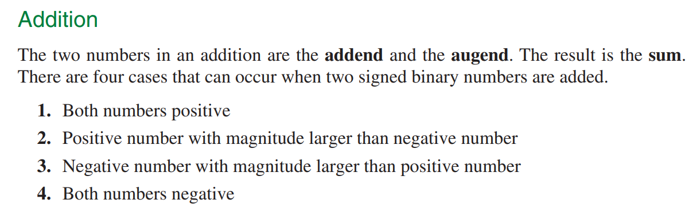

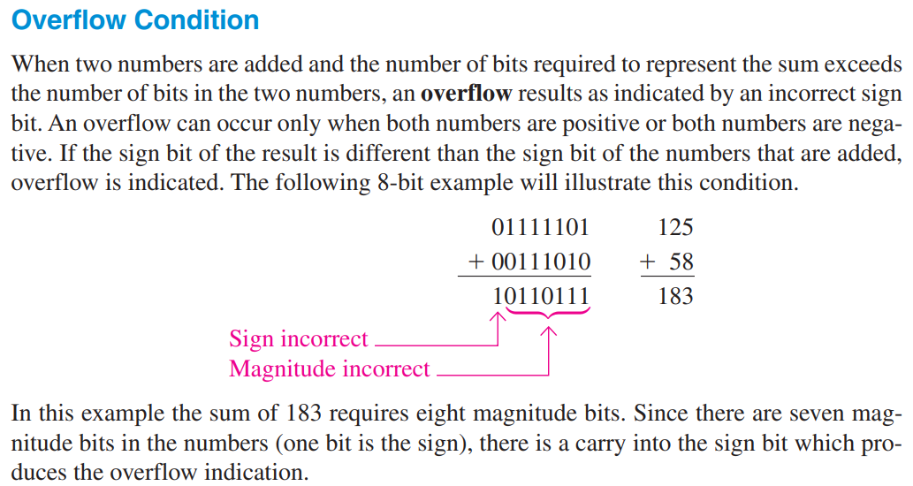

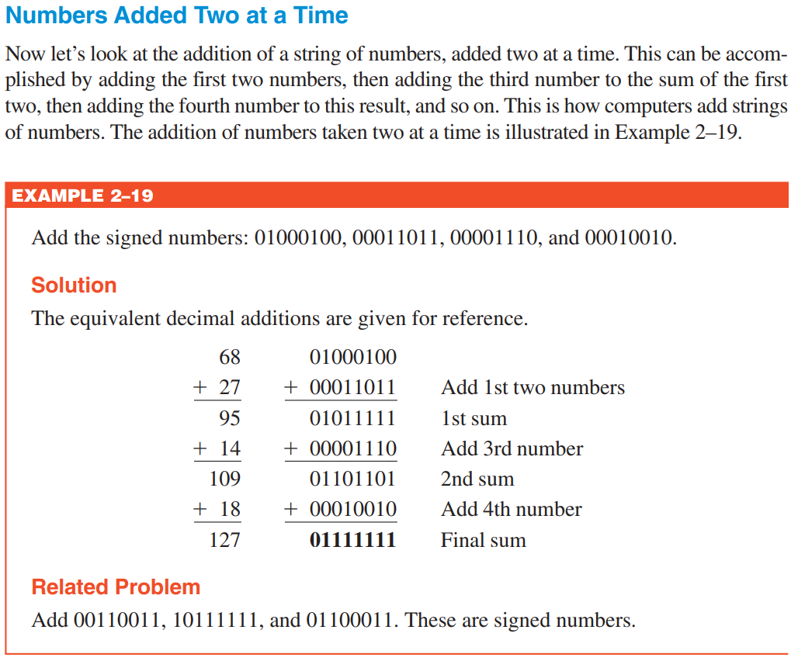

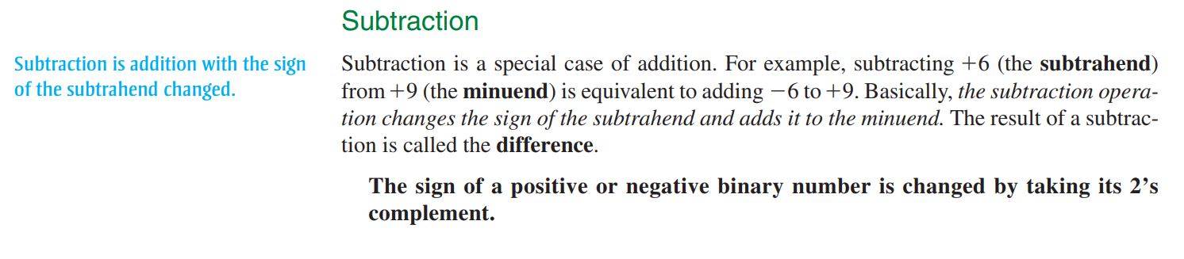

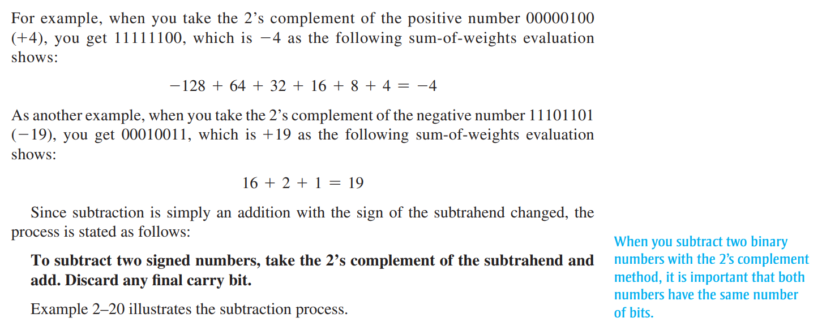

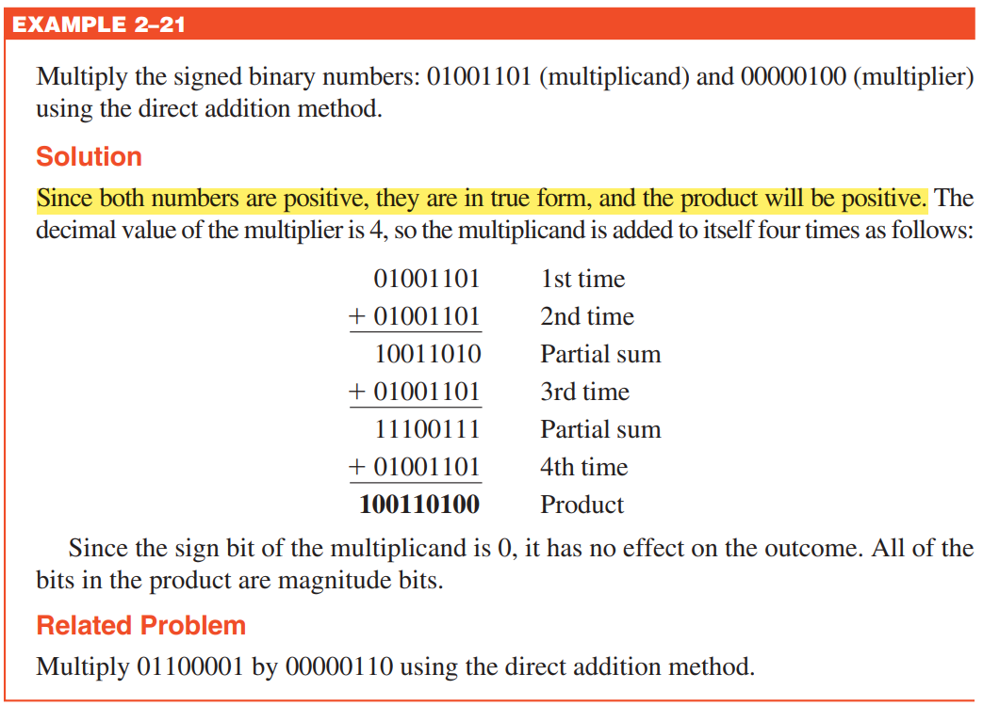

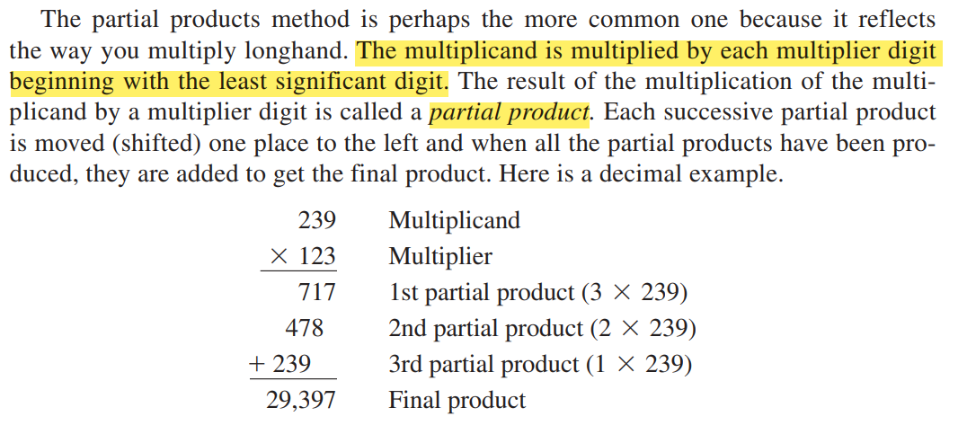

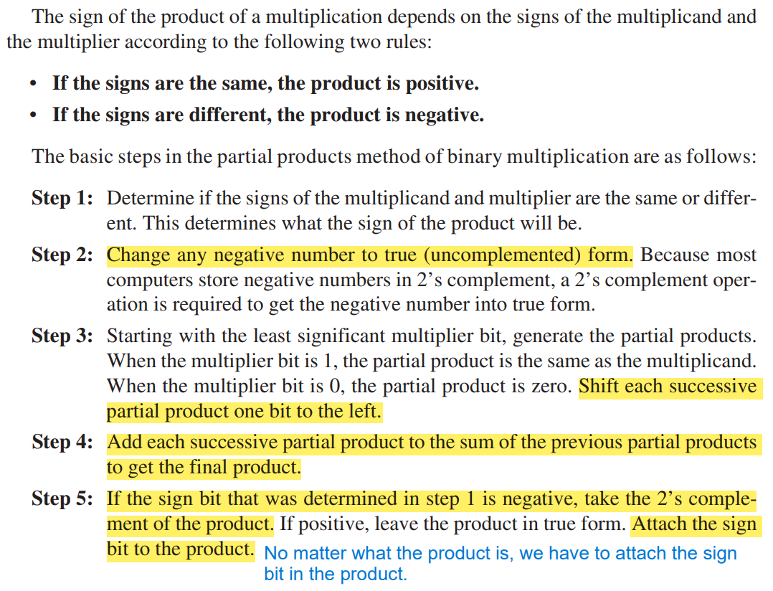

Related Problem: (11000101 = -60) The answer is wrong, because it only took 1’s compliment and did not took 2’s compliment to make the negative number into its true (uncomplimented) form.

Correct answer:

Multiplication after taking 2’s compliment of the multiplier and then using only magnitude bits to perform partial product. Add after each bit is multiplied. Start next bit multiplication with one bit shifted to the left.

Now take the 2’s compliment of the final product and attach the sign bit in the product.



2’s Compliment and then sign bit attached in the final product: 10110010001100

Weight of the final product: -8192+2048+1024+128+8+4 = -4980



